1st STUDENT WELFARE & CAREER DAY  When  December 8th  10.00 – 12.00  Where  CENTRAL CAMPUS, NICOSIA  2 Evagorou Ave., Eleftherias Square, 1st Floor (Library & Cafeteria)  FEATURING · Lidl · Rocket · Zorbas · PAMEUNi · Hlopps · PAWS · Kybella · Euphoria Wellness Spa · Helen Seward · Youth Board Cyprus  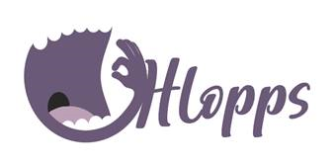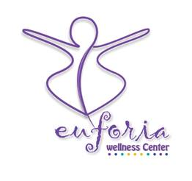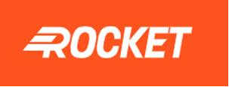  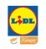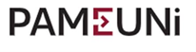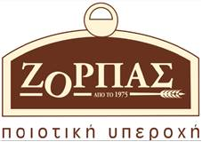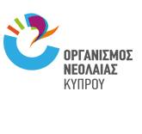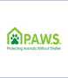  Please make sure to have your vaccination certificate with you at all times plus a 48 hour negative rapid test | APPLY FOR A JOB  GET COUPONS FOR DISCOUNTS  ENJOY CHRISTMAS TREATS  BRING BOOKS, CLOTHES, TOYS YOU DON’T NEED  PLAY TO WIN  